S O U T H W E S T R E S E A R C H I N S T I T U T E
6220 CUl.F;BRA ROAD' POS'T OFFICE DRAWER 28510 ~ SAN ANTONIO, TEXAS. USA 7B22B·0510 • (512) 6B4-5111 • TELEX 244840
CHEMISTRY AND CHEMICAL ENGINEERING DIVISION DEPAR1'MENT Of FIRE TECHNOLOGY FAX (512) 522-3377
December 5, 1991
Flame Safe
2653 Warfield Avenue Fort Worth, Texas 76106
Attn! Mr. Louis Jacobini
Re: SwRI Project No. 01-4510-117-c FINAL REPORT
“Ignition Resistance of Aircraft Interior Materials
(FAR 25.853b 12-Second Vertical)"
Gentlemen:
This letter constitutes our final report on your gray/white striped fabric with fire retardants, identified as lOO-percent Polyester fabric sprayed with Flame Safe flame retardant at 450 sq.ft/gallon, submitted for evaluation by the referenced test method. The samples were prepared by the Client and t0ceived at SwRI ready for testing.
The results apply specifically to the specimens tested, in the manner tested, and not to the entire production of these or similar materials, nor to the performance when used in combination with other materials. All test data are on file and are available for review by authorized persons.
TEST METHOD AND PROCEDURE
The material was tested in accordance with FAR 25. 853b 12-Second Vertical. The test establishes afterflama time and char length on each specimen as applicable.
The specimens were conditioned in accordance with the standard. Each specimen tested was exposed to the test flame within 15 minutes after removal from the standard atmosphere. Each specimen was inserted into the cabinet and the 1-1/2-1n. (38.1-mm) Bunsen burner flame (approximately 1650°F) was applied vertically at the middle of the lower edge of the specimen for 12 seconds.
The afterflnme time of the specimen was recorded to the nearest
0.1 seconds and the char length to the nearest 0.1 in. (2.5 mm). The test criteria for this test are ~8 follows:
Char Length:
Afterflame Drip Burn:
Maximum average> 8 in. Maximum average, 15 seconds Maximum average, 5 seconds
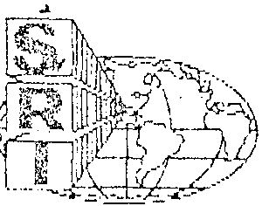
'Thl$ fbpOft is !Clllh3 lnlDrmutio" of the chant. n rY,~y 00 uS-bd in Ita enllr{il'y for tht1 pLJrr--05il (")1 ~ .. beuril~;l pn>;ucl ~C09pt.)n(:j;l. from d~!ly
D'Jn.stitlJlod tlPIXO'Yol u\J(hurrties. NEt~hQf this ffJport nor lh~ Nma of ttib' In&titule sh[111 tw usoo In PlJt~~)tv ex ed'Jal1r.11oQ.
--_.. .-----------.J
SAN ANTONIO, TEXAS
HOUSTON, T"XAS • DETROIT. ,'MICHIGAN •

Flame Safe

SwRI Project No. 01-4510-117-c D~ce111bet 5, 1991
Pccge 2
FAR 25.853b Test Method
TEST SPEClMEN AND NUMBER OF DETERMINATIONS

The specimens were identified as lOO-percent Polyester fabric with Flame Safe flame retardant sprayed at a spread rate of 450 sq.ft/gallon. They were described as gray/white striped fabric with fire retardants. The samples were prepared by the Client and received at SwRl ready for testing. Each specimen was 2.5 x 13 in. (63.5 x 330.2 ~n), nominal thickness 0.28 in. (7.1 mm). A minimum of three specimens were tested in each the machine direction (warp) and the across-machine directions (filling).
TEST R£SULT~>
The test was conducted November 26, 1991, with the following results:
 |  | Run 1 | Run 2 | Run 3 | Average
Char Length, | in. | 6.25 | 6.25 | 6.00 | 6.17
Afterflame, sec. |  | 0.00 | 0.00 | 1. 00 | 0.33
Drip Burn, | sec. | None | None | None | None
Across-Machine Direction:
 |  | Run 1 | Run 2 | Run 3 | Average
Char; Length, | in. | 5.38 | 5.13 | 5.25 | 5.25
After flame, | sec. | 0 | 1. 00 | 1. 00 | 0.67
Drip Burn, sec. |  | None | None | None | None

Based on the aforementioned criteria, the material is considered to have passed the criteria specified in FAR 25.B53b 12-Second Vertical test.

If you should have any questions/comments or if we can be of further assistance, please contact us.
S1ncerely,
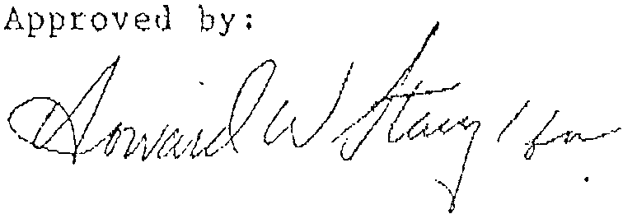
Alex B. Wenzel Director
Department of Fire Technology

~~-0--~~/}) \\\' CJ1\(\~~ GladysM.Finley Project Leader
Fire Testing Services
GHF/rr
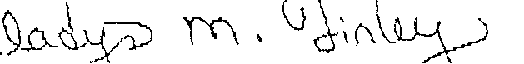

WASHINGTON. DC
[

